http://www.USScouts.Org • http://www.MeritBadge.Org
Please submit errors, omissions, comments or suggestions about this workbook to: Workbooks@USScouts.Org
Comments or suggestions for changes to the requirements for the Belt Loop or Pin should be sent to: Advancement.Team@Scouting.Org
Cub Scout’s Name: Pack No. :
Cub Scouts who earn the BB Gun Shooting Belt Loop while a Wolf Scout
also satisfy Elective 20n (toward Wolf Arrow Points).
Shooting Sports belt loops and pins CANNOT be earned at the pack, den, or individual level.
Shooting Sports are not an approved part of the Cub Scout program, except at Cub Scout day or resident camp.

Cub Scout BB Gun Shooting Belt Loop (See the Pin Requirements below.)
Complete these three requirements:
1. Explain the rules for Safe BB gun shooting you have learned to your leader or adult partner.
2. Demonstrate to your leader or adult partner good BB gun shooting techniques, including eye dominance, shooting shoulder, breathing, sight alignment, trigger squeeze, follow through.
Eye Dominance
Shooting Shoulder
Breathing
Sight Alignment
Trigger Squeeze
Follow Through
3. Practice shooting at your district or council camp for the time allowed.

Cub Scout BB Gun Shooting Pin
Earn the Cub Scout BB Gun Shooting belt loop, and complete five of the following requirements:
1. Explain the parts of a BB gun and demonstrate how to properly load the gun.
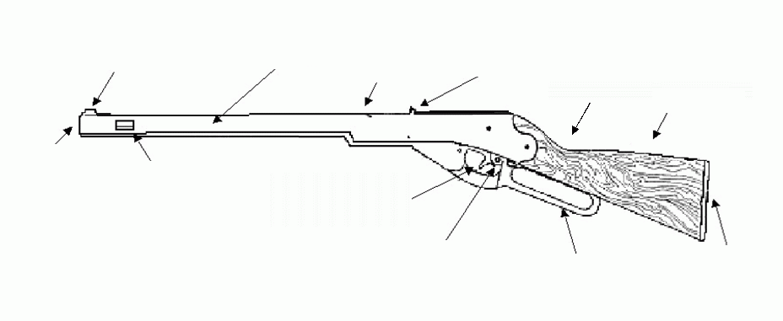
2. Demonstrate the shooting positions.
Prone
Seated
Standing
Kneeling
3. Develop proficient shooting techniques by practicing for three hours.
4. Learn the correct scoring techniques for target BB gun shooting.
5. Make a poster that emphasizes the proper range commands.
6. Draw to scale or set up a BB gun shooting range.
7. Show improvement in your shooting ability with an increase in scoring points.
8 Help make a type of target for the camp BB gun shooting range.
9. Show how to put away and properly store BB gun shooting equipment after use.
10. Explain how to use the safety mechanism on a BB gun.
11 Tell five facts about the history of BB guns.
1.
2.
3.
4.
5.
Requirement resources can be found here:
http://www.meritbadge.org/wiki/index.php/Cub_Scout_BB Gun Shooting#Requirement resources

Important excerpts from the ‘Guide To Advancement’, No. 33088:
Effective January 1, 2012, the ‘Guide to Advancement’ (which replaced the publication ‘Advancement Committee Policies and Procedures’) is now the official Boy Scouts of America source on advancement policies and procedures.
- [ Inside front cover, and 5.0.1.4 ] — Unauthorized Changes to Advancement Program
No council, committee, district, unit, or individual has the authority to add to, or subtract from, advancement requirements. (There are limited exceptions relating only to youth members with disabilities. For details see section 10, “Advancement for Members With Special Needs”.)
- [ Inside front cover, and 7.0.1.1 ] — The ‘Guide to Safe Scouting’ Applies
Policies and procedures outlined in the ‘Guide to Safe Scouting’, No. 34416, apply to all BSA activities, including those related to advancement and Eagle Scout service projects. [Note: Always reference the online version, which is updated quarterly.]
- [ 4.1.0.3 ] ] — Who Approves Cub Scout Advancement?
A key responsibility for den leaders is to implement the core den meeting plans as outlined in the Den & Pack Meeting Resource Guide, No. 34409. For Wolf, Bear, and Webelos advancement, den leaders take the lead in approving requirements, though their assistants, and also parents who help at meetings, may be asked to play the role of “Akela” and assist. Parents sign for requirements that, according to meeting plans and instructions in the handbooks, take place at home. For the Bobcat trail and Tiger Cub achievements, parents (or adult partners) should sign in the boy’s handbook; the den leader then approves as progress is recorded in the den’s advancement record.
- [ 4.1.0.4 ] — “Do Your Best”
Advancement performance in Cub Scouting is centered on its motto: “Do Your Best.” When a boy has done this—his very best—then regardless of the requirements for any rank or award, it is enough; accomplishment is noted. This is why den leaders, assistants, and parents or guardians are involved in approvals. Generally they know if effort put forth is really the Cub Scout’s best.
- [ 4.1.2.2 ] — Cub Scout Academics and Sports Program
More than just a recognition opportunity, this program develops new skills, improves those existing, and otherwise enriches Cub Scouting. Details can be found in the Cub Scout Academics and Sports Program Guide, No. 34299. Activities include subjects like science, video games, collecting, and chess; and sports such as baseball, skateboarding, and table tennis. Each has two levels—a belt loop and a pin. Belt loops, which can be earned more than once, are awarded when each of three requirements is met. Cub Scouts may then continue with additional requirements and earn the pin. Archery and BB gun shooting are included, but can only be conducted at a council presented activity with certified supervisors.
Additional notes of interest:
- BSA shooting sports restrictions:
Tiger Cubs, Cub Scouts, and Webelos Scouts may complete requirements for Belt loops and pins for Archery and BB-Gun Shooting only in Cub Scout/Webelos Scout day camps or resident camps, in council-managed family camping programs, or at council activities where there is properly trained supervision, and all guidelines for BSA shooting sports are implemented.
Shooting Sports belt loops and pins CANNOT be earned at the pack, den, or individual level.
Shooting Sports are not an approved part of the Cub Scout program, except at Cub Scout day or resident camp.
Councils may provide extra opportunities for a boy and his adult partner to continue qualifying for a pin after the council camp experience is over. However, a certified range officer must be present for shooting credits to be valid. The Shooting Sports belt loops and pins can only be awarded by a BSA range-trained shooting-sports director at a BSA approved range. Tiger Cubs must work with their parents or adult partners. Parents and partners do not earn loops or pins.
- “Akela” (Pronounced “Ah-KAY-la”) — Title of respect used in Cub Scouting—any good leader is Akela. Akela is also the leader and guide for Cub Scouts on the advancement trail. The name comes from Rudyard Kipling's Jungle Book. (See "Law of the Pack.")
- “Law of the Pack” — The Cub Scout follows Akela.
The Cub Scout helps the pack go.
The pack helps the Cub Scout grow.
The Cub Scout gives goodwill.

