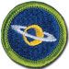 Astronomy
Merit Badge Workbook
This workbook can help you but you still need to read the merit badge pamphlet (book). No one can add or subtract from the Boy Scout Requirements #33215. Merit Badge Workbooks and much more are below: Online Resources.
Workbook developer: craig@craiglincoln.com. Requirements revised: 2011, Workbook updated: March, 2011.

Scout’s Name: Unit:
Counselor’s Name: Counselor’s Ph #:
1. Do the following:
a. Describe the proper clothing and other precautions for safety making observations at night

and in cold weather.

b. Tell how to safely observe the Sun,

objects near the Sun,

and the Moon.

c. Explain first aid for injuries or illnesses such as heat

and cold reactions,

dehydration,

bites and stings,

and damage to your eyes that could occur during observation.

2. Explain what light pollution is

and how it and air pollution affect astronomy.

3. With the aid of diagrams (or real telescopes if available), do each of the following:
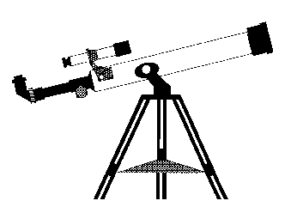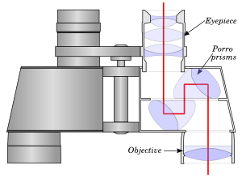
(a) Explain why binoculars

and telescopes are important astronomical tools.

Demonstrate or explain how these tools are used.

(b) Describe the similarities and differences of several types of astronomical telescopes.

(c) Explain the purposes of at least three instruments used with astronomical telescopes.

(d) Describe the proper care and storage of telescopes and binoculars both at home and in the field.

4. Do the following:
(a) Identify in the sky at least 10 constellations, at least four of which are in the zodiac.

(h) Identify at least eight conspicuous stars, five of which are of magnitude I or brighter.

(c) Make two sketches of the Big Dipper. In one sketch, show the Big Dipper’s orientation in the early evening sky. In another sketch, show its position several hours later. In both sketches, show the North Star and the horizon. Record the date and time each sketch was made.
Date:___/___/___ Time: _____ | Date:___/___/___ Time: _____
(d) Explain what we see when we look at the Milky Way.

5. Do the following:
(a) List the names of the five most visible planets. Explain which ones can appear in phases similar to lunar phases and which ones cannot, and explain why.
Five Most Visible Planets Phases? Why?

(b) Using the Internet (with your parent's permission), books, and other resources, find out when each of the five most visible planets that you identified in requirement 5a will be observable in the evening sky during the next 12 months, then compile this information in the form of a chart or table.
Planet Name
Month
(c) Describe the motion of the planets across the sky.

(d) Observe a planet and describe what you saw.

6. Do the following:
(a) Sketch the face of the Moon and indicate at least five seas and five craters. Label these landmarks.

(b) Sketch the phase and the daily position of the Moon, at the same hour and place, for four days in a row. Include landmarks on the horizon such as hills, trees, and buildings.
Date:___/___/___ Time: __________ | Date:___/___/___ Time: __________
Date:___/___/___ Time: __________ | Date:___/___/___ Time: __________
Explain the changes you observe.

(c) List the factors that keep the Moon in orbit around Earth.

(d) With the aid of diagrams, explain the relative positions of the Sun, Earth, and the Moon at the times of lunar and solar eclipses, and at the times of new, first-quarter, full, and last-quarter phases of the Moon.
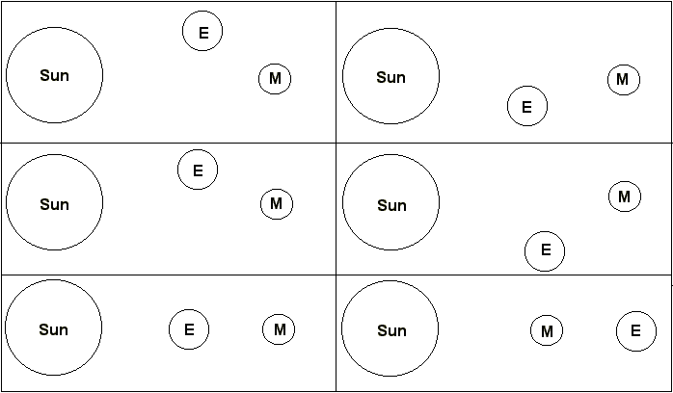
7. Do the following:
(a) Describe the composition of the Sun,

its relationship to other stars,

and some effects of its radiation on Earth’s weather

and communications.

(b) Define sunspots

and describe some of the effects they may have on solar radiation.

(c) Identify at least one red star,
one blue star,
and one yellow star (other than the Sun).
Explain the meaning of these colors.

8. With your counselor's approval and guidance, do ONE of the following:
 a. Visit a planetarium or astronomical observatory. Submit a written report, a scrapbook, or a video presentation afterward to your counselor that includes the following information:
1. Activities occurring there

2. Exhibits and displays you saw

3. Telescopes and instruments being used

4. Celestial objects you observed.

 b. Plan and participate in a three-hour observation session that includes using binoculars or a telescope. List the celestial objects you want to observe, and find each on a star chart or in a guidebook.

Prepare an observing log or notebook. Show your plan, charts, and log or notebook to your counselor before making your observations. Review your log or notebook with your counselor afterward.
 c. Plan and host a star party for your Scout troop or other group such as your class at school. Use binoculars or a telescope to show and explain celestial objects to the group.

 d. Help an astronomy club in your community hold a star party that is open to the public.

 e. Personally take a series of photographs or digital images of the movement of the Moon, a planet, an asteroid or meteoroid, or a comet. In your visual display, label each image and include the date and time it was taken. Show all positions on a star chart or map. Show your display at school or at a troop meeting. Explain the changes you observed.

9. Find out about three different career opportunities in astronomy.

Pick one and find out the education, training, and experience required for this profession.

Discuss this with your counselor, and explain why this profession might interest you.

Online Resources (Use any Internet resource with caution and only with your parent’s or guardian’s permission.)
Boy Scouts of America: ►scouting.org ►Guide to Safe Scouting ►Age-Appropriate Guidelines ►Safe Swim Defense
►Scout ►Tenderfoot ►Second Class ►First Class • Rank Videos ►Safety Afloat
Boy Scout Merit Badge Workbooks: usscouts.org -or- meritbadge.org Merit Badge Books: www.scoutstuff.org

Requirement Resources
These resources and much more are at: http://meritbadge.org/wiki/index.php/Astronomy
1. First Aid
- First Aid Lesson Videos: Basics - Basics2 - Wilderness First Aid - CPR Basics - Venomous Snake Bite - First Aid Kits
- Other First Aid Links: First Aid Merit Badge - First Aid Kit - Mayo Clinic First Aid Guide - Bleeding First Aid Video - Class 1 Exam - Class 3 - Warning Signs of Cancer - Heart Disease
2. Light pollution – Air pollution
3. Binoculars basics - Telescope types and instruments – Telescopes & Types
4a. Constellations – Zodiac Constellations - Eclipses, moon phases, Milky Way, etc.
4b. Conspicuous Stars (brightest)
4c. Big Dipper: diagram
4d. Milky Way
'5a. Planet location and visibility by month - Solar System with planet links - Details on the planets
5b. Monthly planner for upcoming moon and planet events
Constellation Chart for any date, time, and location
Click Select from map to enter your location then click Whole sky chart
6. See above.
7. Moon phases, surface, moon phase video, etc. – All about the moon
7d. See the Astronomy Workbook for the diagrams you will need.
8a. Sun - Encarta Encyclopedia article – Wikipedia article
8b. Notable stars by color - http://en.wikipedia.org/wiki/Star_colors Star Colors with examples]
9. Planetarium – Astronomical Observatory
10. Career opportunities in astronomy.

General Resources
Astronomical League: http://www.astroleague.org Astronomy Watch: http://www.astronomy-watch.com
NASA: http://www.nasa.gov National Optical Astronomy Observatory: http://www.noao.edu
National Radio Astronomy Observatory: http://www.nrao.edu The Planetary Society: http://planetary.org
Sky Maps: http://www.skymaps.com Space Telescope Science Institute: http://hubblesite.org
Sky & Telescope: http://www.skyandtelescope.com/ Space.com: http://www.space.com/
SpaceWander.com: http://www.spacewander.com SpaceWeather.com: http://www.SpaceWeather.com

