http://www.USScouts.Org • http://www.MeritBadge.Org
Please submit errors, omissions, comments or suggestions about this workbook to: Workbooks@USScouts.Org
Comments or suggestions for changes to the requirements for the activity badge should be sent to: Advancement.Team@Scouting.Org
Webelos Scout’s Name: Pack No. :
Do five of these:
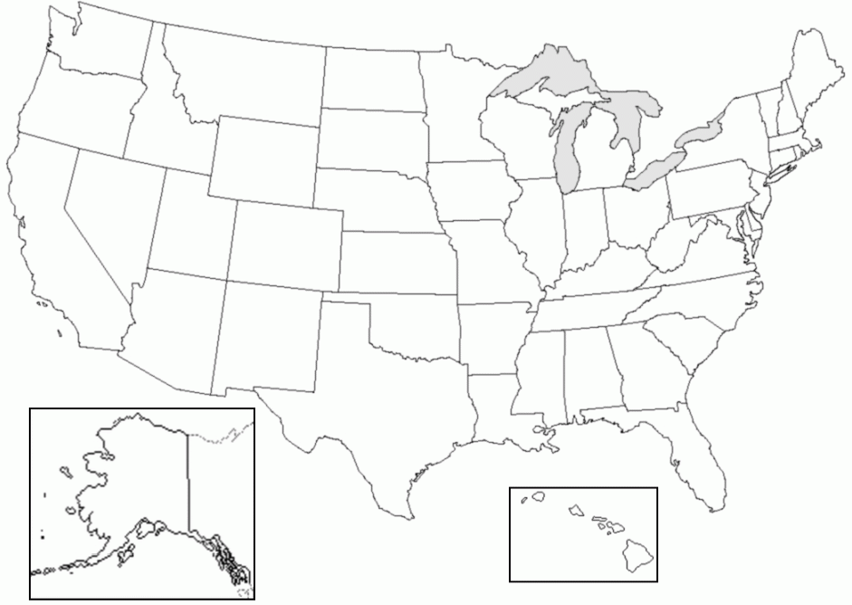
1. Make a map of the United States. Show the types of forests growing in different parts of the country.

Name some kinds of trees that grow in these forests.
Forest Type | Trees that grow in that type of forest
2. Draw a picture to show the plant and tree layers of a forest in your area. Label the different layers. (If you don't live in an area that has forests, choose an area that does and draw a picture of that forest.)
3. Identify six forest trees common to the area where you live. Tell how both wildlife and humans use them. (If you don't live in a region that has forests, read about one type of forest and name six of its trees and their uses.)
 | Tree Type | How do wildlife and humans use them?
1.
2.
3.
4.
5.
6.

4. Identify six forest plants (other than trees) that are useful to wildlife. Tell which animals use them and for what purposes.
 | Plant Type | Which animals use them and for what purposes?
1.
2.
3.
4.
5.
6.

5. Draw a picture showing
how water and minerals in the soil help a tree grow
how the tree uses sunlight to help it grow
6. Make a poster showing a tree's growth rings or examine the growth rings of a tree stump.
Explain how the rings tell its life history
7. Collect pieces of three kinds of wood used for building houses. Tell what kinds of wood they are and one place each of them might be used
1.
2.
3.
8 Plant 20 forest tree seedlings. Tell how you planted them and what you did to take care of them after planting.
9 Describe both the benefits and the harm wildfires can cause in a forest ecosystem.
Benefits:
Harm:
Tell how you can prevent wildfire.
10 Draw your own urban forestry plan for adding trees to a street, yard, or park near your home. Show what types of trees you would like to see planted.
Requirement resources can be found here:
http://www.meritbadge.org/wiki/index.php/Forester#Requirement resources

Important excerpts from the ‘Guide To Advancement’, No. 33088:
Effective January 1, 2012, the ‘Guide to Advancement’ (which replaced the publication ‘Advancement Committee Policies and Procedures’) is now the official Boy Scouts of America source on advancement policies and procedures.
- [ Inside front cover, and 5.0.1.4 ] — Unauthorized Changes to Advancement Program
No council, committee, district, unit, or individual has the authority to add to, or subtract from, advancement requirements. (There are limited exceptions relating only to youth members with disabilities. For details see section 10, “Advancement for Members With Special Needs”.)
- [ Inside front cover, and 7.0.1.1 ] — The ‘Guide to Safe Scouting’ Applies
Policies and procedures outlined in the ‘Guide to Safe Scouting’, No. 34416, apply to all BSA activities, including those related to advancement and Eagle Scout service projects. [Note: Always reference the online version, which is updated quarterly.]
- [ 4.1.0.3 ] ] — Who Approves Cub Scout Advancement?
A key responsibility for den leaders is to implement the core den meeting plans as outlined in the Den & Pack Meeting Resource Guide, No. 34409. For Wolf, Bear, and Webelos advancement, den leaders take the lead in approving requirements, though their assistants, and also parents who help at meetings, may be asked to play the role of “Akela” and assist. Parents sign for requirements that, according to meeting plans and instructions in the handbooks, take place at home. For the Bobcat trail and Tiger Cub achievements, parents (or adult partners) should sign in the boy’s handbook; the den leader then approves as progress is recorded in the den’s advancement record.
- [ 4.1.0.4 ] — “Do Your Best”
Advancement performance in Cub Scouting is centered on its motto: “Do Your Best.” When a boy has done this—his very best—then regardless of the requirements for any rank or award, it is enough; accomplishment is noted. This is why den leaders, assistants, and parents or guardians are involved in approvals. Generally they know if effort put forth is really the Cub Scout’s best.
- [ 4.1.2.2 ] — Cub Scout Academics and Sports Program
More than just a recognition opportunity, this program develops new skills, improves those existing, and otherwise enriches Cub Scouting. Details can be found in the Cub Scout Academics and Sports Program Guide, No. 34299. Activities include subjects like science, video games, collecting, and chess; and sports such as baseball, skateboarding, and table tennis. Each has two levels—a belt loop and a pin. Belt loops, which can be earned more than once, are awarded when each of three requirements is met. Cub Scouts may then continue with additional requirements and earn the pin. Archery and BB gun shooting are included, but can only be conducted at a council presented activity with certified supervisors.
Additional notes of interest:
- Webelos Scouts may complete requirements in a family, den, pack, school, or community environment.
- “Akela” (Pronounced “Ah-KAY-la”) — Title of respect used in Cub Scouting—any good leader is Akela. Akela is also the leader and guide for Cub Scouts on the advancement trail. The name comes from Rudyard Kipling's Jungle Book. (See "Law of the Pack.")
- “Law of the Pack” — The Cub Scout follows Akela.
The Cub Scout helps the pack go.
The pack helps the Cub Scout grow.
The Cub Scout gives goodwill.

